**A Novel Method of QRS Detection Using Time and Amplitude Thresholds with Statistical False Peak Elimination**

**ABSTRACT:**

Heartbeats are crucial to the medical sciences' study of heart ailments because they reveal significant details about heart problems and irregular heart rhythms. The electrocardiogram (ECG) records each heartbeat as a QRS complex that is focused at the R-peak. Analysis of the ECG is hampered by variations in QRS shape, low-frequency noise, high-frequency noise, interference from P and T waves, and low-frequency noise. In order to improve peak detection performance, this study introduces a new peak detection method that can suppress noise and adjust to variations in ECG signal morphology. The suggested approach is founded on segmentation, time and amplitude thresholds, statistical false peak elimination, and median and moving average (MA) filtering (SFPE). To eliminate undesired noise and interference, the filters are first applied during preprocessing. A time axis (x-axis) threshold and an amplitude (y-axis) threshold are used to examine each segment of the data after it has been separated into smaller segments. Next, the erroneous peaks caused by any remaining noise are removed using the average peak-to-peak interval. Any peak that is spotted twice is removed, and a post-processing stage is introduced to look for missed low-amplitude peaks. The suggested strategy outperforms a number of cutting-edge approaches in the field when tested on the MIT-BIH arrhythmia and Fantasia databases. For the MIT-BIH arrhythmia database and the Fantasia database, the mean sensitivity, positive predictivity, and detection error rates for the suggested technique are 99.82%, 99.88%, and 0.31 percent, respectively.

**EXISTING SYSTEM:**

Similar to most other QRS detection techniques, the proposed method consists of two stages: a preprocessing stage and a peak detection stage, as shown in the block diagram in Fig. 1. The preprocessing is carried out block-by-block, the size of each block being N, to have a local estimate of noise in the denoising operation. The preprocessing is carried out in a series of steps that aim at suppressing the noise peaks and the P- and T waves, and accentuating the QRS complexes. Since the preprocessing is done block-by-block, edge effects can occur after filtering, because of abrupt truncation, and hence, false peaks can be detected at the block boundaries. To avoid this issue, symmetric padding is done on the blocks on both sides before filtering, by using reflecting boundary conditions.

**DISADVANTAGES:**

* The method is not very good extracting peaks.
* The method doesn’t consider of very low peaks.
* The method is not effective at detection of q and s peaks.

**PROPOSED METHOD:**

The noise filtered ECG signal will be sent to the Peak detection stage where the peaks are detected using Amplitude and Time Thresholds. The thresholds for estimating the QRS peaks. The thresholds are done based on the statistical analysis of the ECG signal. The thresholds are the values that result in the typical QRS peaks or waves. The particular Q peak or R peak or S peak will have a regular time instants or lengths or heights. These can be used to threshold to extract the near exact Q or R or S peaks. The peak detection will be more better whenever there is better thresholds. For that we have to remove the noise at a greater value. The R peaks are the most and easily detectable among all of the ECG peaks. The typical tallest peak or that which peak that has highest amplitude in an ECG signal is always an R peak. So, the R peaks are easily be extracted and can be used for reference in estimating the other peaks. Like the difference between the two R peaks and the threshold difference between the QR peaks as well as RS peaks. So, the threshold will result in better way, if the R peaks are detected perfectly.

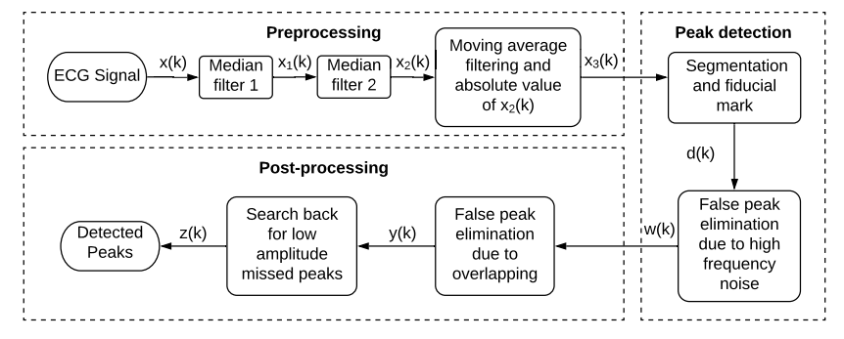

**Fig 3.1 Block Diagram of Existing Method**

**ADVANTAGES:**

* The SFPE algorithm is quite good at thresholding.
* SFPE algorithm is effective in the case of low amplitude peaks.
* SFPE algorithm is also effective in the case of removing noise that degrades the signal

**APPLICATIONS:**

* Applied in DSP applications
* ECG Peak Detection
* Bio-Medical Signal Processing
* Image Processing

**Software & Hardware Requirements:**

**Software:** Matlab R2018a.

(Simulink)

**Hardware:**

**Operating Systems:**

• Windows 10

• Windows 7 Service Pack 1

• Windows Server 2019

• Windows Server 2016

**Processors:**

Minimum: Any Intel or AMD x86-64 processor

Recommended: Any Intel or AMD x86-64 processor with four logical cores and AVX2 instruction set support

**Disk:**

Minimum: 2.9 GB of HDD space for MATLAB only, 5-8 GB for a typical installation

Recommended: An SSD is recommended a full installation of all Math Works products may take up to 29 GB of disk space

**RAM:**

Minimum: 4 GB

Recommended: 8